Celestial Forecast (6.9~6.15)
未来一周天象预报（6.9~6.15）
Original author: Alan MacRobert
原文作者: Alan MacRobert
Translator: Mingxuan Liu
翻译：刘明轩
Proofreader: Keyi Wang、Yuxin Qiu、and Congyi Wang
校对: 王克义、邱煜欣、王聪怡
Editor: Zhuo Chen
编排： 陈卓
Website Link: https://www.skyandtelescope.com/observing/this-weeks-sky-at-a-glance-june-7-15/
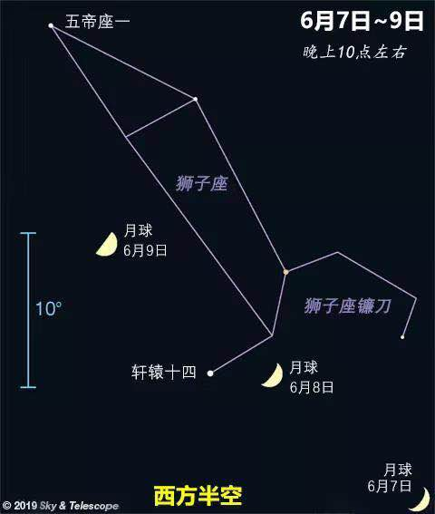
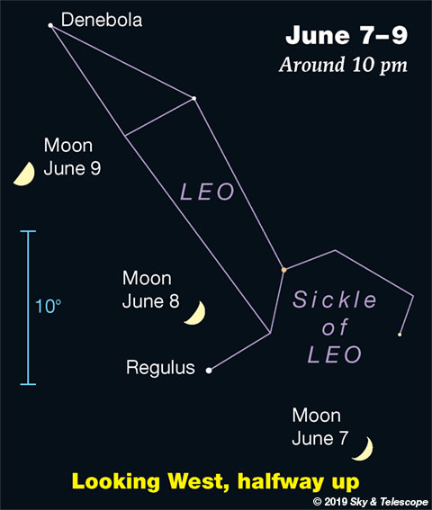
原文链接：https://www.skyandtelescope.com/observing/this-weeks-sky-at-a-glance-june-7-15/
当月亮穿过狮子座的时候，它正在逐渐趋近于上弦月。（蓝色的比例尺是你伸直手臂时一拳的宽度）

Sunday, June 9
星期日，6月9日，农历五月初七
First-quarter Moon (exact at 1:59 a.m. tonight EDT). The Moon shines in the hind feet of Leo. Look 10° above it (about a fist at arm's length) for Denebola, the tip of Leo's tail.
Almost twice as far to the Moon's lower right is Regulus, Leo's forefoot.
月亮悬挂在狮子座的两腿之间。在它的右下方不远处你可以找到轩辕十四（狮子座α），这头狮子的前脚。
再往左上方15°上下寻找，你可以看到五帝座一（狮子座β），正是狮子座的尾巴尖。

Monday, June 10
星期一，6月10日，农历五月初八
Jupiter is at opposition tonight, opposite the Sun as seen from Earth. It's that bright white point in the southeast after dark. It's in southern Ophiuchus, to the left of orange Antares and the other, lesser stars of upper Scorpius.
And despite an ignorant news report that's circulating all over the world, you can see Jupiter's moons with binoculars anytime Jupiter is up — not just at opposition! Who creates this nonsense?
上弦月（北京时间13：59）。木星也将位于今晚冲日，在地球的另一侧与太阳刚好相对。日落后木星在东南天空中成为一个白点，位于蛇夫座，处在心宿二（天蝎座α）和天蝎座上方其他更暗淡恒星的左侧。
当木星升起时你随时都可以用你的双筒望远镜观测它的卫星—谁说木卫只有在冲日的时候才能看见？

Tuesday, June 11
星期二，6月11日，农历五月初九
Spica sparkles to the lower left of the Moon this evening. More than twice as far upper left of the Moon is brighter Arcturus.
今晚角宿一(室女座α)将在月亮的左下方闪耀。在月亮左上方两倍与角宿一距离的位置，是更加耀眼的大角星（牧夫座α）。

Wednesday, June 12
星期三，6月12日，农历五月初十
Now Spica is lower right of the moon, and Arcturus shines high above them.
今晚角宿一仍在月亮左下方位置，而明亮的大角星悬挂在更高的天空。

Thursday, June 13
星期四，6月13日，农历五月十一
With summer only 8 days away, the Summer Triangle stands high and proud in the east after dark. Its top star is bright Vega. Deneb is the brightest star to Vega's lower left (by 2 or 3 fists at arm's length). Look for Altair a greater distance to Vega's lower right.
距离夏至还有8天，日落后夏季大三角正明显地悬挂在东方天空。最上方的是织女星（天琴座α）。而天津四（天鹅座α）是织女星左下方（伸直手臂后约两到三个拳头的宽度）最亮的星。同时，你也可以在织女星右下方更远处寻找牛郎星（天鹰座α）。

Friday, June 14
星期五，6月14日，农历五月十二
Look far below the Moon in late twilight and after dark for Antares and Jupiter, as shown here.
The Big Dipper now hangs straight down by its handle as the stars come out, high in the northwest.
夜幕降临时你可以在月亮的下方找到心宿二和木星。
当群星浮现在天空中时，西北方的北斗七星的勺柄正竖直冲下。
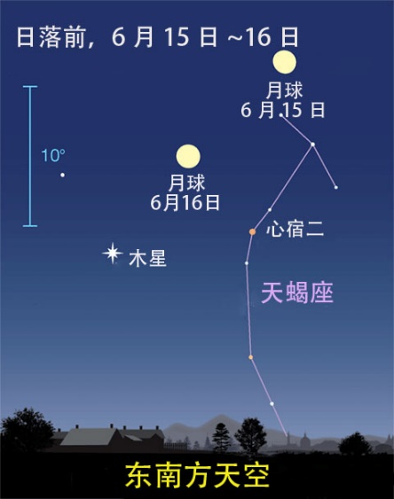
盈凸月在16日经过心宿二和木星，并形成一个等腰三角形。
Saturday, June 15
星期六，6月15日，农历五月十三
Now the bright Moon forms a not-quite-equilateral triangle with Jupiter to its lower left and Antares to its lower right, as shown here. Think photo opportunity. The triangle is 10° from end to end, so use a moderately long lens. Or even try zooming in with a phone camera braced rock-steady.
从图中你可以看到，明月正与左下的木星和心宿二形成一个十分完美的等腰三角形。此时你可以考虑拍几张双星伴月的照片。这个等腰三角形的两个底角大约是10°，所以你可以使用长镜头。或者你也可以尝试使用手机放大的功能拍摄，但前提是你的镜头要足够稳。

This Week's Planet Roundup
本周行星动态（未标红的不适宜观测）

Mercury (in Gemini) glimmers low in evening twilight. Look for it in the west-northwest about 45 to 60 minutes after sunset. This week it fades by almost half, from magnitude –0.6 to –0.1. Don't confuse Mercury with twinklier Procyon some 25° to its left, or Capella about the same distance to its right.
水星 （位于双子座）暮光中在地平线附近闪耀。日落后45到60分钟内在西北偏西处寻找它。这周它的形状只剩下原来的一半，视星等从-0.6降至-0.1等。不要把它和更加明亮的南河三（小犬座α）或者右方相同距离处的五车二（御夫座α）搞混。
Venus (magnitude –3.8) is very low in the dawn. About 20 minutes before sunrise, scan for it with binoculars a little above the east-northeast horizon.
金星（视星等-3.8）曙光中在地平线附近。日出20分钟前，你可以使用你的双筒望远镜在东北偏东处寻找它。
Mars (a mere magnitude +1.8, in Gemini) is upper left of much-brighter Mercury as evening twilight fades away. Their separation closes rapidly, from 8½° on June 7th to 2½° on the 14th. Pollux and Castor watch from above.
Mercury and Mars will appear closest together, a mere ½° apart or less, on June 17th and 18th.
火星 （位于双子座，视星等1.8等）当暮光消褪时位于更加明亮的水星左上方。他们间的距离迅速减小，从6月7日的8.5°减小到6月14日的2.5°。北河二（双子座α）和北河三（双子座β）正在它们的上方悄悄闪耀。
火星和水星将在6月17日和6月18日距离达到最小，仅为0.5°。
Jupiter (magnitude –2.6, in southern Ophiuchus) is at opposition on June 10th. This week it glares low in the southeast by late twilight. Antares, much fainter at magnitude +1.0, twinkles about 10° to its right. Jupiter is highest in the south by around midnight or 1 a.m. daylight saving time, with orange Antares now to its lower right.
In a telescope Jupiter is 46 arcseconds wide. See Bob King's Jupiter Is Outstanding at Opposition. And big changes continue in and around Jupiter's Great Red Spot, as seen in the images here.
木星 （位于蛇夫座，视星等-2.6等）在6月10日冲日。当暮光消褪时它在东南方低空闪耀。视星等为1的心宿二在它右侧距离为10°的位置。木星在凌晨1点钟到达上中天，橙红色的心宿二在右下方做伴。
Saturn (magnitude +0.3, in Sagittarius) rises around the end of twilight. It's the steady, pale yellowish "star" about 30° east of Jupiter. Saturn's opposition comes July 9th.
土星 （位于人马座，视星等0.3等）在曙光褪尽时出现。它在木星东侧30°左右，看起来像是一个稳定且苍黄色的“恒星”。土星将在7月9日冲日。
Uranus is still deep in the glow of dawn.
天王星 隐没在黎明的光芒中。
Neptune (magnitude 7.9, in Aquarius) is in the east-southeast just before dawn begins, far lower right of the Great Square of Pegasus. Finder chart.
海王星 （位于宝瓶座，视星等7.9等）在曙光出现前位于东南偏东的天空，飞马座四边形的远下方。

Original Article
A Key Step in Detecting Interstellar Molecules——alcohol, acetic acid, and aldehyde for example
Jack, Jane, Sophie, Stephanie
Abstract
Introduction
The existence and structures of interstellar organic molecules play a positive role in helping astronomers to learn about collision between atoms, formation of lives, and evolution of stars. To meet this end, representative spectra for certain molecules need to be discerned from observation results. The aim of this study was to determine optimal absorbance wavelengths of alcohol, acetic acid, and aldehyde and illustrate the mechanism underlined with molecular orbital theory, revolution theory, and vibration theory.
Experiment
The paper includes the materials and the instrument with its introduction for using it. We also demonstrate the method to utilize all materials and instrument with which the experiment being hold. The essential instrument we use is UV scanning and the main substances we use as samplings are Aldehyde, Acetic acid and Alcohol.
Results
Alcohol and acetic acid show no absorbance in the span between 200 nm and 700nm. Aldehyde, in contrast, shows two clear absorbance peaks, respectively at 230 nm and 298 nm.
Analysis
Transitions of electrons from low-energy orbitals to high-energy orbitals assumed most absorbance of ultraviolet light in certain wavelengths. Representative wavelengths could be used to determine functional groups in molecules passed by light from nebulae or stars. Plus, vibrations and revolution of molecules afford rest absorbance and make spectra continuous, which can be determined by the equation of radiation transfer.
Conclusion
We want to extent the method of searching interstellar molecules in outer space and we hope this process of experiment can enlighten some way of searching. Three organic substances are the samplings when we choose for a better choice for conducting. The results can be clearly seen and based on the statistics we got from the experiment we can figure out a likely way to confine objects in outer space.
Keywords:
Alcohol, Acetic acid, Aldehyde, wavelength, interstellar organic molecules

Introduction
The existence and structures of interstellar organic molecules play a positive role in helping astronomers to learn about collision between atoms, formation of lives, and evolution of stars. To meet this end, representative spectra for certain molecules needs to be discerned from observation results. The aim of this study was to determine optimal absorbency wavelengths of alcohol, acetic acid, and aldehyde and illustrate the mechanism under-lied with molecular orbital theory, revolution theory, and vibration theory.

At present, 47 kinds of molecules have been found in interstellar space, and 80% of which are organic molecules. The discovery of interstellar molecule and interstellar organic molecule breaks away from the dominant view in astronomy that atoms in interstellar space are difficult to bind to molecules, even if they bind to molecules, they will be disintegrated. Interstellar organic molecules are studied by analyzing the microwave lines emitted by molecules through radio telescopes. The discovery of interstellar organic molecules helps us understand the evolution of nebulae and stars, and increases the possibility of extraterrestrial life, which is the basis of interstellar chemistry today. Therefore, it is also known as one of the four great discoveries of astronomy in the 1960s. Using ultraviolet spectrophotometer is the most common treatment for determination of optimal wavelength of organic molecules, so we choose this method to carry our experiment.

In conclusion, this research would determine optimal absorbency wavelength of polar molecule relating both chemistry and physics and explain why some results are not observed, which divides into four parts named experiment, result, analysis and conclusion.

Experiment
The Preparation of Solutions
1. Calculate the mass of acetic acid, ethanol and acetaldehyde according to n=m/M
2. Use the electronic balance to measure the mass of the three materials
3. Put the three substances in a small beaker and dilute them with a little water.
4. After the solution temperature is lowered, transfer the three substances in the beaker to a 500 mL capacity bottle.
5. Wash the beaker and transfer the glass rod, at least three times, then transfer the washing water to the capacity bottle.
6. Add water to the calibration line, and change the volume fixing with rubber head burette about one centimeter away from the calibration line.
7. Shake well the solution, and if the liquid level drops, water cannot be added to set volume.
8. Transfer the solution to the reagent bottle and label it.

Method to use the ultraviolet spectrum
1. First, we charge the UV spectrometer. Except preheating the UV spectrometer, we also need to test the basic function of the machine and initialize it. Then we open the computer.
2. We then take out the medicine or the samplings from the UV spectrometer and close the machine and then open the particular software.
3. We need waiting for the initialization which detects eight elements. There are some cautions including tritium lamp energy detection without taking out the samplings in the groove should be avoided.
4. After we finish the testing, there will pop up five windows. One main window is a small one and then we choose the [UV scanning] and put the control group in the machine. Then we click the [base] in the right tool column to wait for the scanning finished. Then we take out the control group on the outer side and put them in testing group and then click [begin] and to begin the scanning.
5. After scanning, we right click the screen and then we can see the program aiming to dispose the picture. We should set the range of axis and the way tracing point.
6. We then click the left side profile and choose to preserve the picture in the column. Although the preservation can only be served as the form which can be opened in the software, we can screenshot the picture.

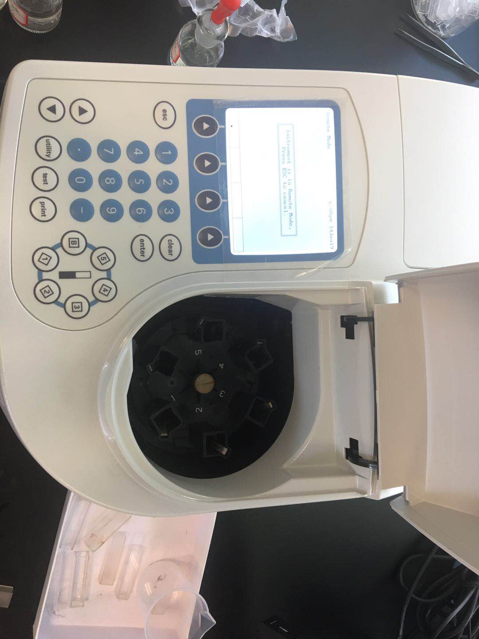
Figure-1

Results

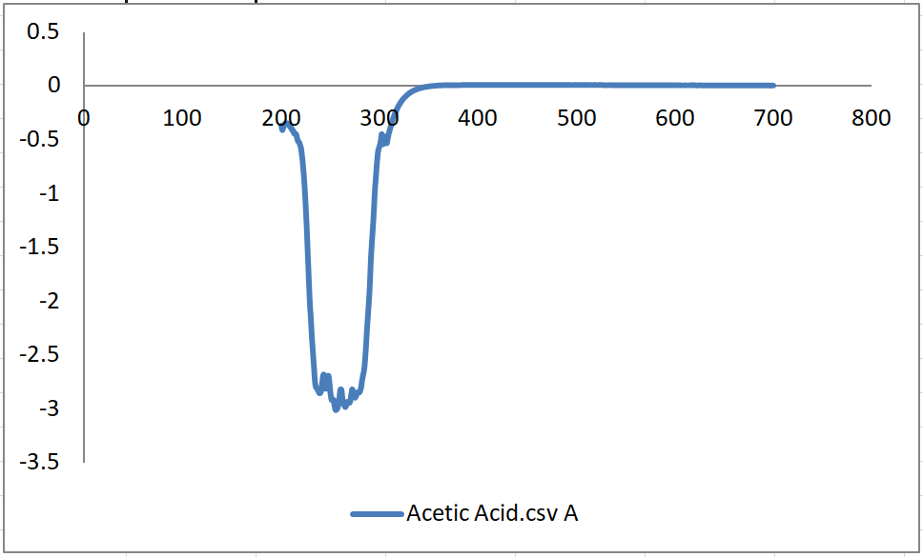
Figure-2.1

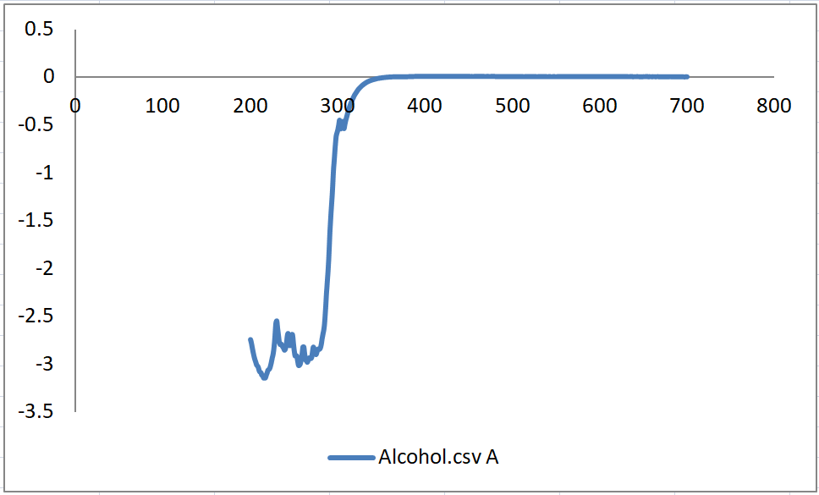
Figure-2.2
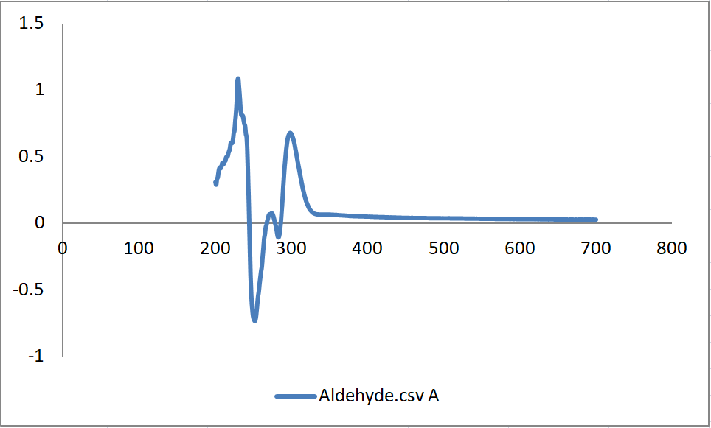
Figure-2.3

Analysis
Absorbance spectrum is the record of particles’ sequence and strength of absorbance. It indicates the presence, concentration, and structure of particles tested. Different from band spectra obtained from atoms, spectra of molecules have continuous features due to electrons’ transition and molecules’ vibration and revolution.

Molecules are in certain energy levels, where higher energy levels are reached when molecules are exited and lower levels returned to ground state, as can be described by the equation $∆E=E_{1}-E_{0}=ην$.

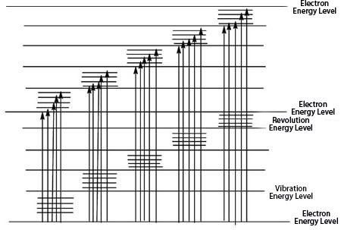
Energy levels in molecules are much more complicated than those of atoms. Total energy of molecules is composed of multiple parts, following this equation $E_{Total}=E_{I}+E_{T}+E_{E}+E_{V}+E_{R}$. $E_{I}$ refers to internal energy, with no relation to molecules’ transition in energy level since internal energy remains the same during transitions. $E_{T}$ refers to molecules’ translational kinetic energy, only as a continuous function of temperature and with no correlation with transitions between energy levels. $E_{E}$ here refers to valence electron energy, the energy produced when electrons move relatively to the nucleus, and assumes most energy transitions, where two nearby energy levels have a difference of 1-20eV. $E_{V}$ refers to vibrational energy, which is produced when molecules vibrate around the equilibrium position and which affects spectra produced and provides information of bond types, and have a 0.025-1 eV difference between two nearby energy levels. $E_{R}$ refers to rotational energy, which is produced when molecules revolve around the gravity center and affects received spectra, has a difference of 0.004-0.025eV between two nearby energy levels, and gives information about bond lengths, bond types, and hyperfine structures of molecules, observed in infrared spectra. $E_{V}$ and $E_{R}$ assume the vacancy between two electron energy levels and make the spectra continuous. Therefore, it can be determined that in transition process only involves $E_{E}$,$E_{V}$, and $E_{R}$.
Figure-3.1

If the molecule absorbs energy less than 0.025eV, only revolution of the molecule is involved. If the molecule absorbs infrared light, both its vibrations and revolutions are evoked. If the molecule absorbs light of wavelengths between 200 nm and 800 nm, transitions of electrons are produced, and ultraviolet-visible spectra occurs. Thus, when there are transitions of electrons, there must be vibrations and revolutions, which correspond to lower energy level and produce continuous spectra, as shown by the following figure.

Organic molecules, such as acetic acid, aldehyde, and alcohol used in the experiment, absorb mainly the ultraviolet light due to electrons transitions. Molecules with double bonds or multiples bonds—— that is, molecules with resonance structures—— are most likely to have obvious absorbance.

According to the Molecular Orbital Theory, organic molecules possess following several orbitals of electrons around nuclei. First, sigma (σ) molecular orbitals. The electron probability of both molecular orbitals is centered along the line passing through the two nuclei. Electrons in sigma orbitals are referred as sigma electrons. For bonding orbital, the probability is between the nuclei, and for the antibonding either side. A bonding molecular orbital is lower in energy than the atomic orbitals of which it is composed. The bonding orbital is formed when phases of both orbitals match between the nuclei to produce constructive interference. This leads to enhanced electron probability between the nuclei. Electrons in this type of orbital will favor the molecule; that is, they will favor bonding. An antibonding molecular orbital is higher in energy than the atomic orbitals of which it is composed. The antibonding orbital is formed by the direct combination of the orbitals, which gives destructive interference of the positive phase of one orbital with the negative phase of the second orbital. This produces a node between the nuclei, which gives decreased electron probability. Electrons in this type of orbital will favor the separated atoms. Second, pi (π) molecular orbitals. The electron probability of both molecular orbitals lies above and below the line between the nuclei. Electrons in pi orbitals are referred as pi electrons. Following the same mechanism of sigma orbitals, bonding orbitals are formed when phases of two parallel orbitals match, and antibonding appears if positive phase of one orbital meets the negative phase of the other orbital. All in all, molecular sigma and pi orbitals can be formed only when the symmetry of two orbitals matches. Third, n molecular orbitals. Electrons in these orbitals are referred as n electrons and do not interact with electrons in the orbital of the other nucleus.

In the molecular orbital model, electrons still conform with Pauli Exclusion Principle, Aufbau Principle, and Hund Rule.

When organic molecules absorb certain amount of energy, valance electrons will transit to higher energy levels, which can be categorized as following 4 types. First, N to V transition. Electrons in this transition are transferred from the ground state to the antibonding orbital. Second, N to R transition. Electrons in this transition are transferred from the n orbital to the antibonding orbital. Third, N to R transition. Electrons in this transition are excited gradually from sigma orbitals to higher energy levels, finally ionizing the molecule. Fourth, transition of charges. Charges in this transition are redistributed and transferred to other parts within the molecule. In terms of energy, these transitions can be ranked as following:
$$σ→σ^{*}>n→σ^{*}>π→π^{*}>n→π^{*}$$

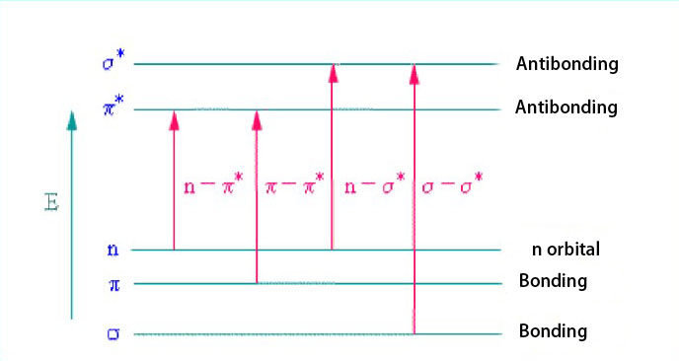
Figrue-3.2

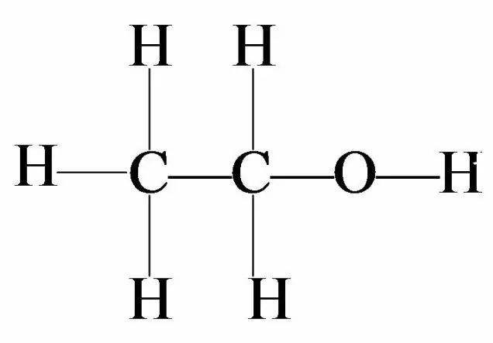
In this experiment, where samples are scanned through 200 nm to 700 nm, alcohol and acetic acid have negative absorbance values. The mechanism of the spectrometer is simultaneously setting up a comparison sample—— which is water here since our solutions are diluted with water—— and testing samples. After receiving the absorbance of testing samples，softwire VISIONite subtracts the received value of absorbance with that of the water. Here some parts of absorbance of alcohol and acetic acid are negative. We can get clues of their respective molecular structures.
Figure-4.1

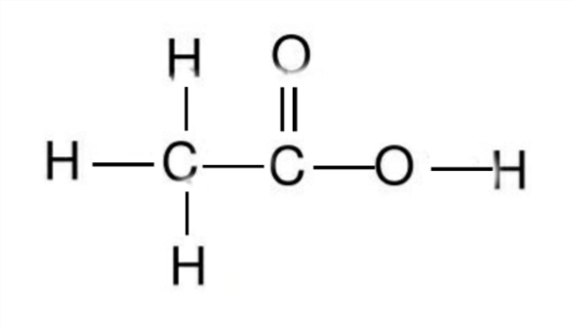
Above is the molecular structure of alcohol, which has only sigma (σ) electrons. Therefore, there is only $σ→σ^{*}$ transition occurring when excited. This type of transition requires high energy, which especially occurs in the carbon bond in organic molecules, and appear in the span between 10 nm and 200 nm; that is, it is in the far-ultraviolet region. This pattern explains why in the absorbance spectrum of alcohol shows no absorbance in the span of wavelength between 200 and 700 nm, which is the only region scanned by our Ultra-visible spectrophotometer.
Figure-4.2

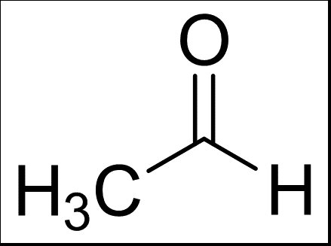
Similarly, acetic acid also does not show absorbance between 200 nm and 700 nm. $n→σ^{*}$ occurs and also requires relatively high energy, and absorbance appears in nearly 183 nm_{[6]}. Hydroxyl here acts as auxochrome lengthening the wavelength of absorbance. The fact is, absorbances of alcohol and acetic acid are detectable as long as in the right span of wavelength, which is feasible in astronomical observation.
Figure-4.3

In contrast, aldehyde shows two clear peaks of absorbance. To calculate the energy of absorbance, we need to use the Plank Formula $E=\frac{hc}{λ}$. The first one shows an absorbance wavelength of 230 nm and absorbance energy of 5.394 eV. K absorbance band occurs due to $π→π^{*}$ transition. As the conjugate system enlarges, the influence of π electron cloud decreases, thus energy required smaller and wavelength much larger. K absorbance band is the representative characteristic of organic molecules, which can then be used to determine the conjugate structure in molecules. The second one shows an absorbance wavelength of 298 nm and 4.163 eV. R absorbance band occurs due to $n→π^{*}$ transition, caused by the conjugate group in aldehyde. Normally, $n→π^{*}$ transition needs relatively small amount of energy and thus have a larger absorbance wavelength than that of K absorbance band.

Besides, electron transitions are demonstrated by ultra-violet spectra, whereas vibrations of molecules are showed by infrared spectra. Vibrations of molecules can be approximated as simple harmonic motion and comply with the Hooke’s Law. Also, the revolution of molecules help make the spectrum continuous, giving astronomers a glimpse into hyperfine structure_{[7]}. Here is the radiation transfer equation:
∑n(i)×C(i , l)+ i
∑n(i)×B(i , l)×U(i , l)+ i
∑n(i)×A(i , l) i
= ∑n(l)×C(l , i)+ i
∑n(l)×B(l , i)×U(l , i)+ i
∑n(l)×A(l , i)

Conclusion
By conducting this experiment and analysis, we want to further explore the possible method to detect objects in the outer space. The samplings (Alcohol, Acetic acid and Aldehyde) are organic substances and can be shown their ultraviolet absorption and obvious spectrum easily. When it occur in the outer space which may contains floating tremendous objects able to be detected their ultraviolet absorption, the experiment and the result in the paper can be a good lighthouse for further research about interstellar molecules.

Literature Review
[1] Karas, Michael.， Bachmann, Doris.， Hillenkamp, Franz, Influence of the Wavelength in High-Irradiance Ultraviolet Laser Desorption Mass Spectrometry of Organic Molecules. Analytical Chemistry 57(14) · December 1985
[2] Peter L. Smith, Ultraviolet observations of interstellar molecules and grains from Space lab. Proceedings of the Astronomical Union 1980, vol 81, pp 645-660
[3]
John H. Black, Ultraviolet-visible-and-infrared-spectroscopy-of-interstellar-molecules. Highlights of Astronomy 1981, pp. 331-338
[4] Black, J. H, Visible and ultraviolet studies of interstellar molecules. Molecular Astrophysics 1985, pp 215-236
[5] Molecular motion corresponds to three levels of electronic energy level, vibrant energy level and rotational energy level. https://wk.baidu.com/view/e9821f6c580102020740be1e650e52ea5518cede
[6] The Maximum Absorption of Wavelength https://wk.baidu.com/view/3f5db4ac951ea76e58fafab069dc5022aaea46a9
[7] Fei CHUN, Interstellar Molecules and their spectra. Journal of Atomic and Molecular Physics, April 2004.

